950467818

Base URL:

**Agreement URL:**

|  |
| --- |
| http://www.zgflzz.cn/EN/1000-6621/current.shtml  1)Go to the website using based URL |

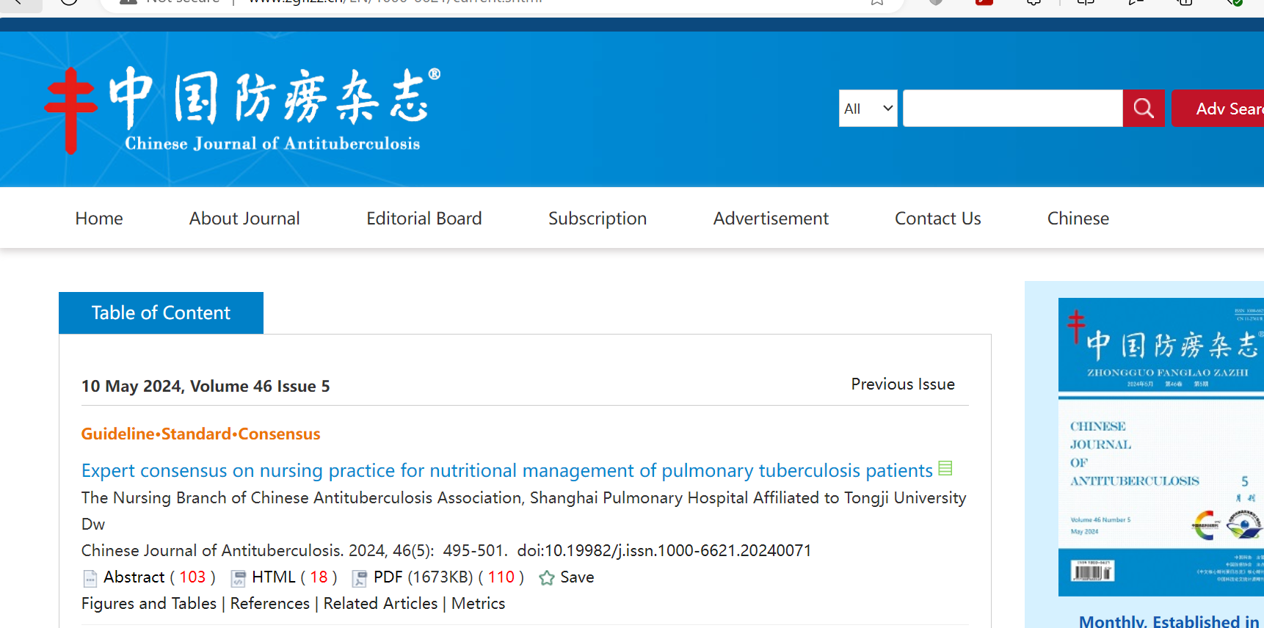

2)Capture date

3)Capture month

6)Capture issue

4)Capture year

7)Capture article title

8)Capture DOI

9)Capture page range

5)Capture volume

10)Click pdf button to download

11)need to capture non roman and English toc for this title. For that right click and save as pdfs and merge in to one.